***Decentralized real estate platform***

*Work document*

Second Report (06/12/2018)

* **Group member:**

**Dương Hoàng Linh**

**Nguyễn Minh Tâm**

**Nguyễn Phi Hùng**

Content

**1.** **Introduction** 3

**a.** **Target** 3

**b.** **Importance:** 3

**2.** **Related works** 3

**3.** **Diagram** 4

**a.** **Bussiness Functional Diagram:** 4

**b.** **Data Flows Diagrams (3 levels)** 4

- Level 0: 4

- Level 1: 6

- Level 2: 6

**4.** **Blockchain** 9

**5.** **Front-ends** 9

**6.** **Prerious report** 11

# **Introduction**

* 1. **Target**
* Build a real estate platform for Smart City, which allows:
* Real estate owners:

+ Log in as a lessor (homeowner)

+ Initialize / edit / delete rental property information

+ Verify the owner of that property

+ Negotiate terms with tenants

+ Review rental history

+ Revenue and Cost Management

* Real estate tenant:

+ Log in as a tenant

+ Search by location / price / nature of properties

+ Re-negotiate terms with the owner

+ Real estate rental

* This platform provides payment systems such as electronic money (ETH / BTC / ...), real money (ATM / VISA / ...).
* Each property will have a limit list of owners (verified by ID). When the tenant agrees to rent, his or her ID will be added to the tenant's limited list for the negotiated lease period.
* This platform reduces commissions for both owners and tenants, and transactions more quickly.
  1. **Importance:**
* This platform creates a transaction environment with low commission costs, faster transactions. Reduce the spurious cases in real estate. Maintain transparency through smart contract.

# **Related works**

* Customers in Hawaii have about 50 real estate, half for local residents and the rest for tenants during vacation.
* For vacationers, customers use the AirBnB service, but the commission costs for AirBnB are very high and transactions are slow.
* Airbnb (AirBed and Breakfast), a startup that connects people with rental needs around the world through a mobile application similar to the Uber car sharing application. . All payments will be made through Airbnb, using a credit card and the mediator will charge a fee to both the reservation and the host.

# **Diagram**

* According to Airbnb website and some related examples, we have drawn some diagrams to illustrate main features for our project included existing ones and some additional features which are created from us.
  1. **Bussiness Functional Diagram:**

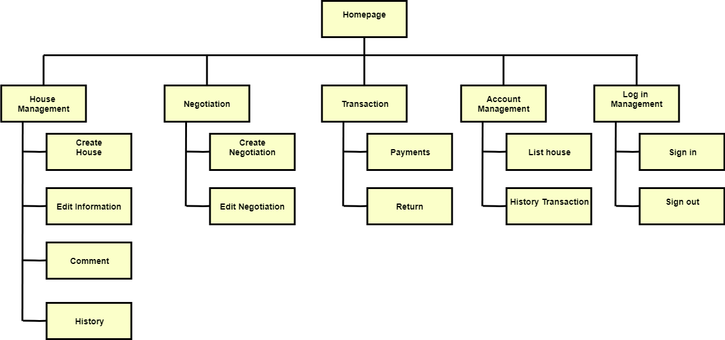

## **Data Flows Diagrams (3 levels)**

* Level 0:
* There are two main factors/instances in our project, we call them Homeowner and Tenant. Both sides have to provide their identify key for verifying their own identity. We also need those keys for getting user’s information.

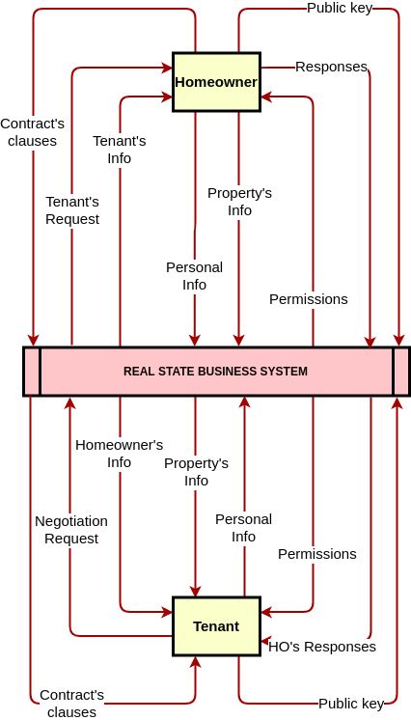

* Level 1:

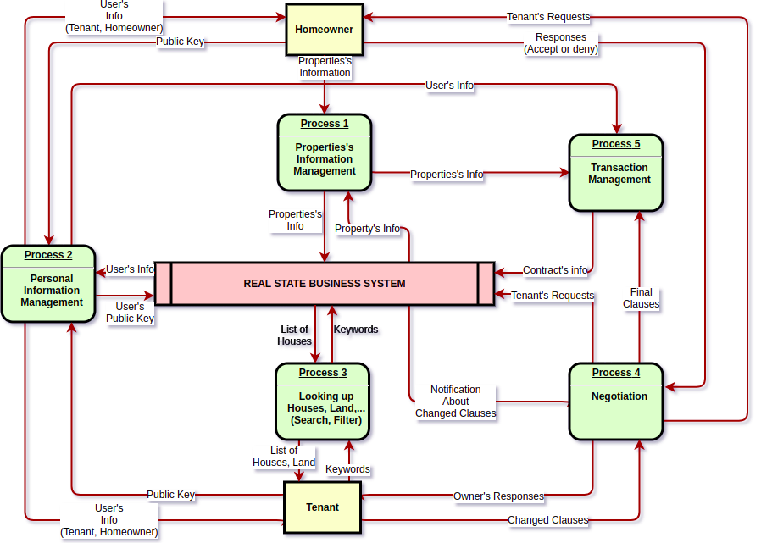

* Level 2:

Process 1: Property management

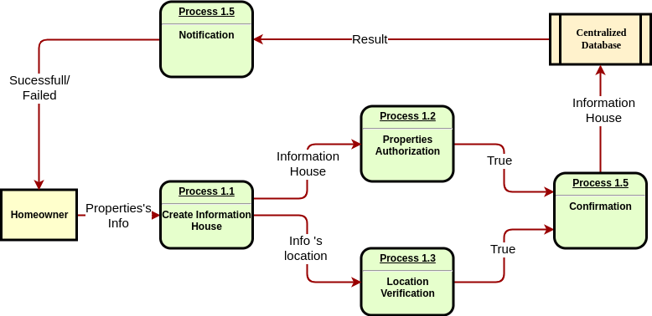

Process 2: Personal Info Management

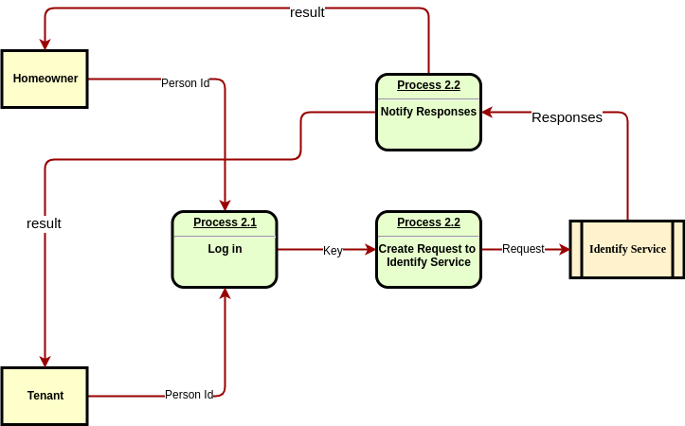

Process 3: Looking up property

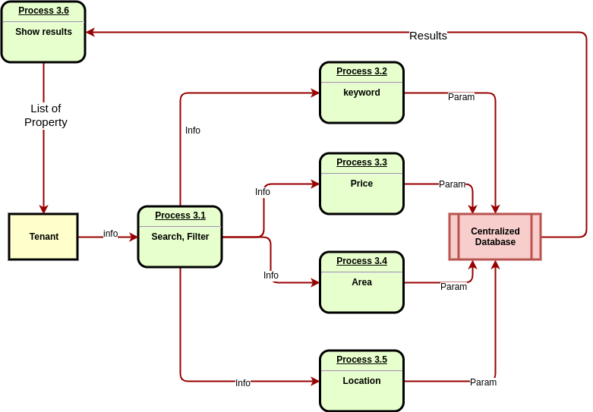

Process 4: Negotiation

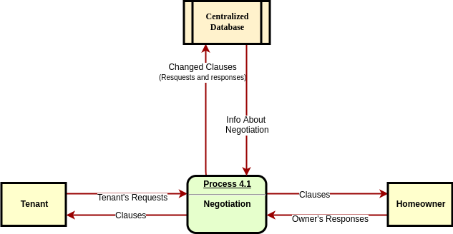

Process 5: Transaction management

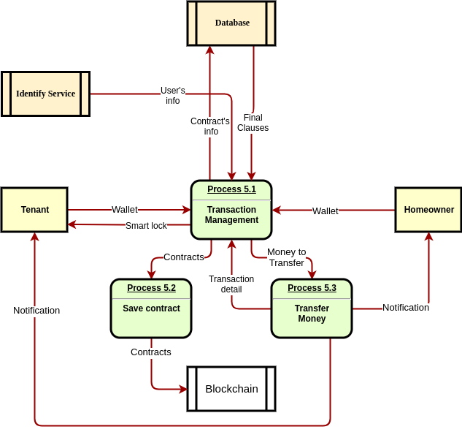

# **Blockchain**

* We decided to use client-server architecture for this project. We will build separately an API as a back-end service with a front-end (written in HTML/CSS/JS).
* Blockchain is responsible for storing immutable data, such as contract details and historical user transactions.
* An API will be written in NodeJS using MVC architecture and interact with Smart Contracts through Web3.js library.

# **Front-ends**

* Online link: https://real-estate-uit.herokuapp.com/

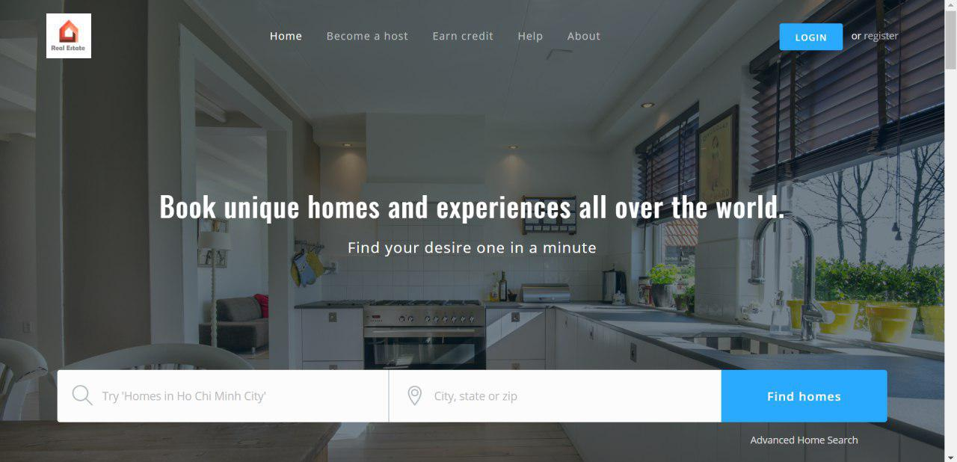

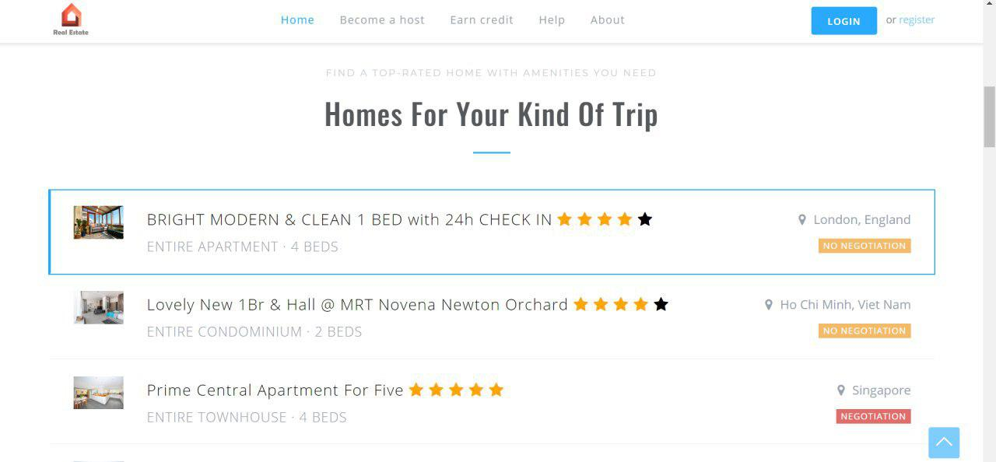

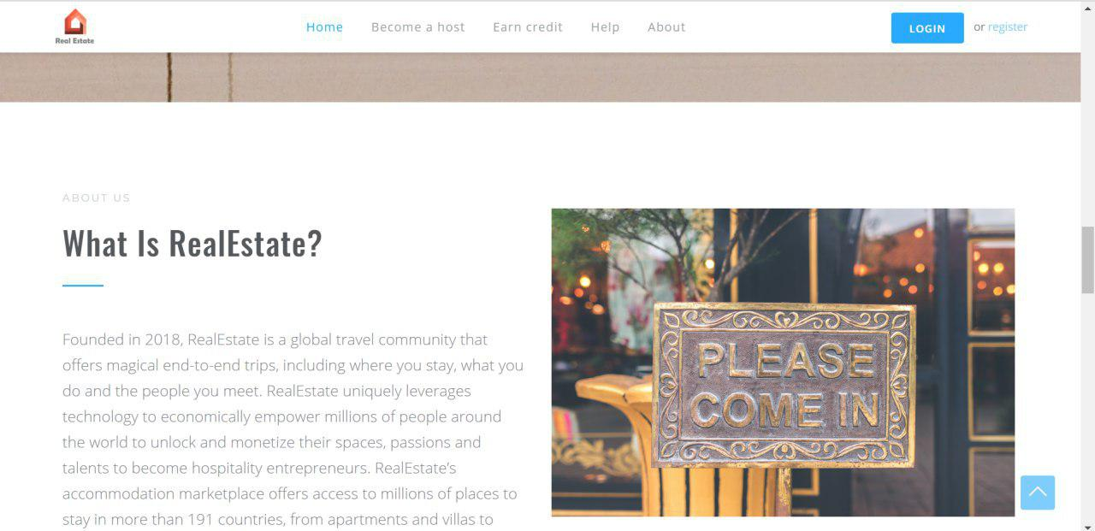

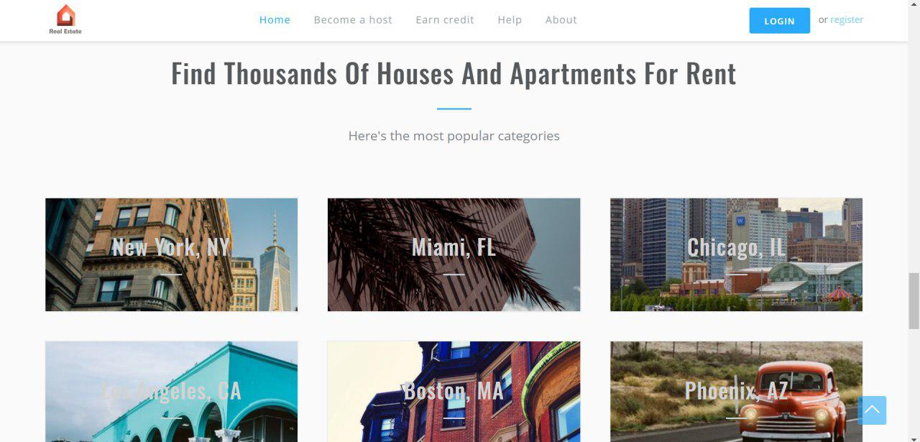

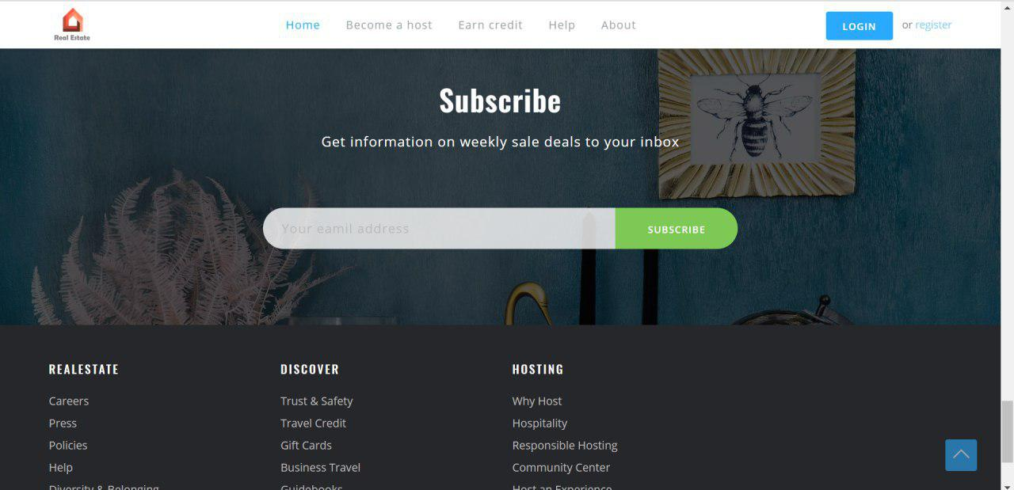

# **Trouble**

* We encountered some difficulties in saving bigdata into blockchain:

+

# **Prerious report**

* First week report: <https://uithcm-my.sharepoint.com/:p:/g/personal/15520421_ms_uit_edu_vn/EfOr55zTLC1IsjUAmXV_6msBHSgJdN_aKgsaNe-bLDZEQQ?e=zE83gE>